**1) Verify System Dates:**

* **Process:** Check the date on DW (Data Warehouse) and IREP side.
* **Purpose**: Ensure synchronization between systems

**2) File Reception Check:**

* **Process**: Confirm if files have been received at the designated path.
* **Purpose**: Validate data availability for processing.

**3) Run Trade Load Staging Job on 10.1.10.15:**

* **Process**: Execute the Trade Load Staging job on 10.15 if files are received.
* **Purpose:** Load transactional data for further processing.

**4) Verify NDM File Archival:**

* **Process**: Check if NDM files are successfully archived.
* **Purpose:** Ensure data persistence and availability for reference.

**5) Kick off Recursive IREP EOD Job:**

* **Process**: Initiate the IREP End of Day job.
* **Purpose**: Execute necessary operations for IREP system closure.

**6) Kick off Recursive BPSA Job**:

* **Process:** Trigger the Recursive BPSA job for comprehensive processing.
* **Purpose:** Perform system-wide calculations and updates.

**7) DW Portal Check:**

* **Process:** Access the DW Portal to monitor file statuses.  
  **Portal Link:** EOD Status Portal (<http://10.1.10.5:8000/Internal/EODStatus>)
* **Purpose:** Track the progress of file processing and identify any pending or running tasks.

**Sample of File Status after DW Portal Check:**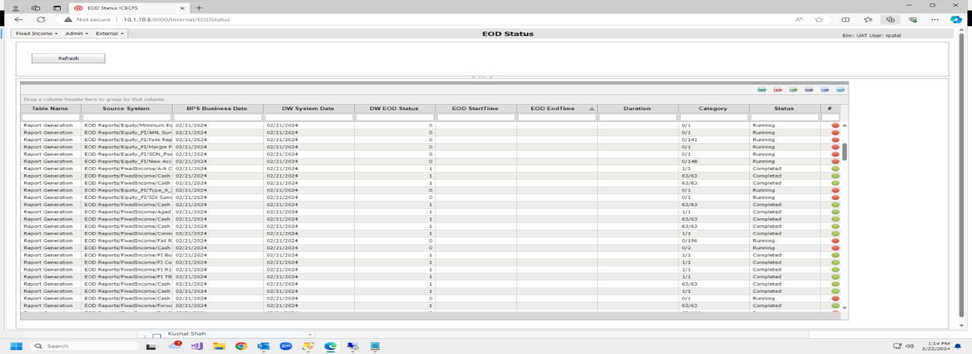

**Business Rationale:**

* **Date Verification:**  
  Ensures consistency in reporting and processing across different systems.
* **File Reception Check**:  
  Validates the availability of necessary data for daily operations.
* **Trade Load Staging**:  
  Facilitates the seamless integration of transactional data into the system.
* **NDM File Archival:**  
  Guarantees data integrity and preserves historical records.
* **IREP EOD Job**:  
  Executes essential end-of-day operations within the IREP system.
* **Recursive BPSA Job:**  
  Executes essential end-of-day operations within the BPSA system.
* **DW Portal Check:**  
  Provides real-time visibility into the status of critical files and tasks, allowing for proactive issue resolution.

**Conclusion:**  
The End of Day process ensures the integrity of data, completeness of operations, and readiness for the subsequent business day. Regular monitoring through the DW Portal enhances visibility and allows for swift responses to any inconsistencies in the system. This comprehensive approach ensures a smooth transition between business days, supporting the organization's operational efficiency and data reliability.